June 26, 2018

12th Five Flavours Asian Film Festival – First program announcements
The eyes of the whole world keep turning towards Asia, whose political and cultural significance rapidly increases year by year. Once again, Five Flavours invites you to discover Asian reality from the inside. The Festival is a perfect opportunity to immerse yourself in gripping pop culture, take part in heated debates about the crucial social changes, and to see the works of renown masters of cinema.
Year of the dog
Following the tradition of the previous years, the visual identification of the Festival is inspired by the lunar calendar. 2018 is the year of the Dog, which symbolizes honesty, loyalty, openness to dialog, and a joyful, friendly nature.
Asian Cinerama
Since 2007, Five Flavours teams up with Asian Film Awards Academy, the institution supporting the promotion of high quality commercial cinema from Asia. The result of this collaboration is a section made up of stunning genre cinema, and the newest hits by renown filmmakers, nominated and awarded at this years Asian Film Awards gala.
Presented in the section is one of last year’s most important Chinese productions, "Youth" (China, 2017) by Feng Xiaogang, who is often called the Chinese Spielberg. This widely commented work of the popular director is an offbeat look at the era of Cultural Revolution – a story of a group of young artists preparing shows for the army. The nostalgia with which their first loves and adolescent dilemmas are portrayed is paired up with the tragedy of the historical changes taking place in the background. The songs from the times of Mao are still very emotive for the older generations of Chinese viewers, but the director is looking for new means to talk about those extremely difficult times. The vast success of the film testifies to the fact that it is a topic the audience is ready to debate.
Special Screenings
Five Flavours never fails to showcase the films which are particularly important for Asian cinema, and the works of filmmakers our audiences are familiar with. One of the masters returning to our program is Pen-ek Ratanaruang, whose retrospective was presented at the 3rd Five Flavours. The newest film of the Thai genre cinema specialist, "Samui Song" (Thailand, Germany, Norway 2017), is a stylish psychological thriller inspired by the works of Hitchcock and the 1960s melodramas. Dark sexuality, a mysterious sect, and a desperate decision of the heroine – Ratanaruang knows how to keep the audiences on their toes, surprising them with unexpected mood shifts.
Other representatives of the Thai New Wave appear as co-authors of the project "Ten Years Thailand" (Thailand, Hong Kong, Japan 2018), presented at this year’s festival in Cannes. It is a continuation of the cycle opened by the famous Hong Kong "Ten Years," showcasing the potential social changes which can take place in the near future as a result of current political decisions. The Thai version of the film, made up of several novellas, was created by Chulayarnnon Siriphol, Apichatpong Weerasethakul, Wisit Sasanatieng, and Aditya Assarat, who took up this arthouse, science-fiction project to convey their visions of the upcoming decade. The allegorical, and the very literal images reflect not only on the situation in Thailand, but also on the wider, though not necessarily brighter, future of the world.
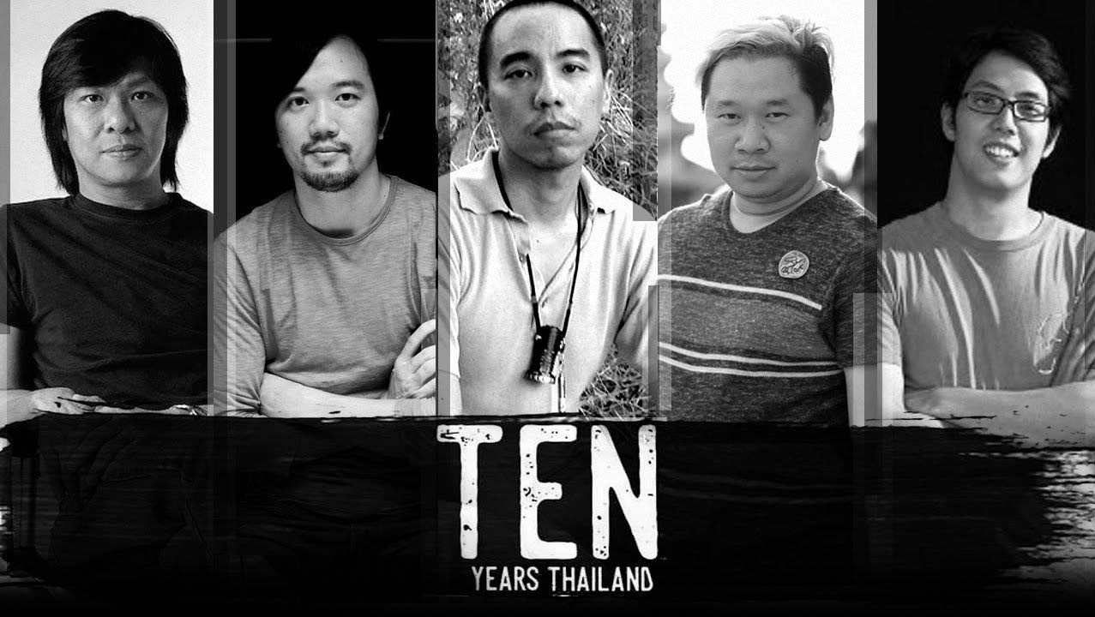
Focus: Philippines
The cinema of the Philippines has one of the oldest traditions and richest film outputs in the region – this year marks its 100th anniversary. The last decade was a time of its dynamic development, both in terms of commercial productions and the achievements of new generations of independent filmmakers. Numerous auteur pieces by Filipino artists have been screened at international festivals, showing the diverse, often unexpected images of the culture of the country. Apart from the vivid portraits of the busy streets of Manila, the cinema of the Philippines offers unique stories from its seven thousand islands, numerous personal essays, and strong plots, uncompromisingly appraising the actions of the government.
The filmmakers often speak about the surrounding reality using the tools of genre films, from action cinema to musicals, wrapping the ambitious substance in a unique form, and shifting the boundaries of cinema. Individual biographies, the colonial past, contemporary issues of violence, poverty, and the disparities in the growing wealth of the society – everything has its place in the country’s rich cinema, which is going through its third "golden era."
New Asian Cinema
Like in the previous years, the main axis of the festival is the competition section presenting new auteur cinema from countries such as Taiwan, Hong Kong, Malaysia, Japan, China, and Thailand. The Q&A sessions with festival guest after the screenings are a great opportunity to discuss art, cinephile fascinations, and contemporary culture. New Asian Cinema is a meeting space for the avant-garde aesthetics, controversial statements, formal experiments, and fresh voices commenting on the modern Asian reality.

12th Five Flavours Asian Film Festival – Warsaw, November 14-21
Festival passes available from August 1st.
Organized by: Arteria Art Foundation
Partners: Warsaw City Council, Polish ministry of Culture and National Heritage, Asian Film Awards Academy
More information: www.piecsmakow.pl
Follow us on Facebook, Twitter, and Instagram, read blog.piecsmakow.pl.

