For immediate release
22 June, 2017
Five Flavours Films: New Distributor in Poland
After a decade of operating as an Asian film festival, Five Flavours expands the scope and adds theatrical distribution in Poland to its label. It fills the local niche in the Asian film market.

Asian films are a rarity in Polish cinemas with only a few titles being released each year, some of which face very limited arthouse distribution, what makes Polish audience watch most of them film festivals. Asian releases neither receive much media publicity.
Creating the new distribution label, Five Flavours aims to fill this gap in the local market and bring more attention to Asian cinema in Poland throughout the year, not only before and during Five Flavours Film Festival which tends to take place in Autumn.
As a distributor, Five Flavours focuses on full length features. At least three films - including Cannes and Berlinale titles - will be released theatrically in Poland by early spring 2018.
The first Five Flavours picture is the critically-acclaimed Filipino drama "Apocalypse Child" directed by Mario Cornejo and produced by Monster Jimenez. It is scheduled to be released on 6 October, 2017. Special screenings at selected summer festivals in Poland are planned before the regular distribution. "Apocalypse Child" was crowned the Best Film at the 10 edition of Five Flavours which took place in Warsaw in November, 2016.
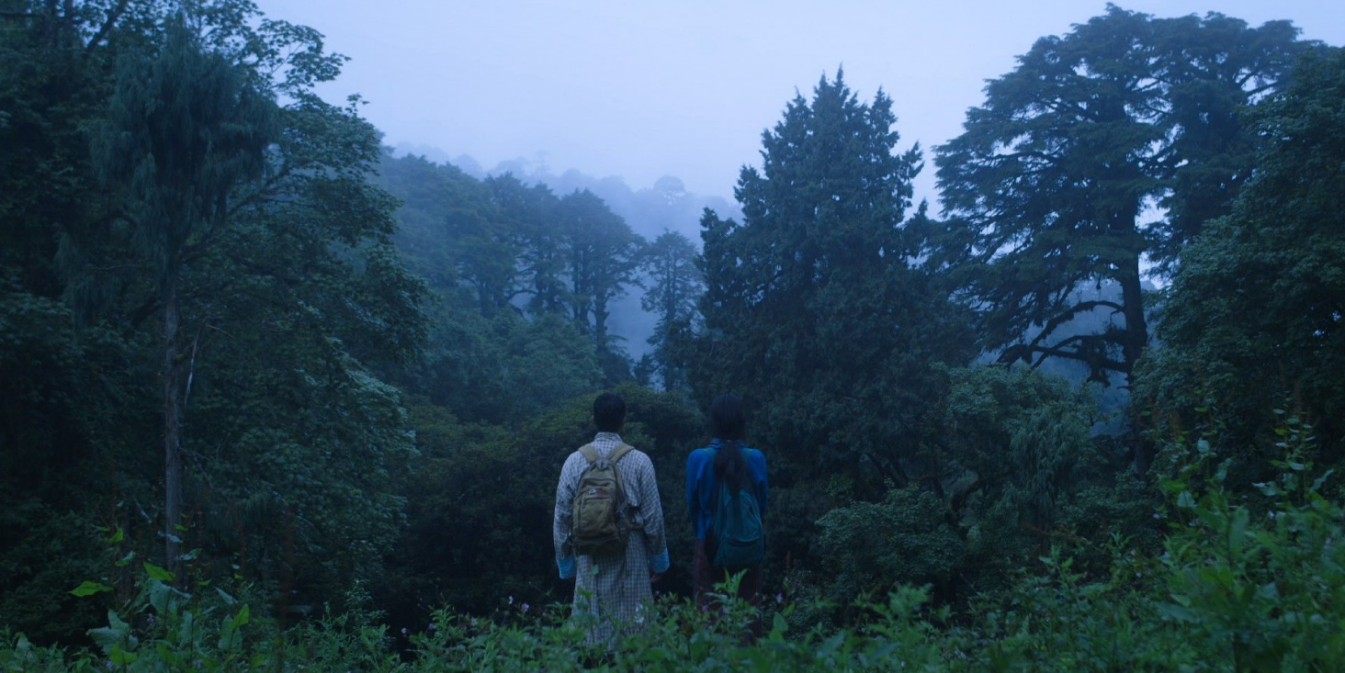
Further titles in the delicious catalogue are Bhutanese mystery thriller "Honeygiver Among the Dogs" by Dechen Roder and Indonesian feminist western "Marlina the Murderer in Four Acts" from Mouly Surya, presented respectively at this year's Berlinale and Cannes festivals. Both choices highlight that Five Flavours is a distributor open to explore any genre.
Honeygiver Among the Dogs

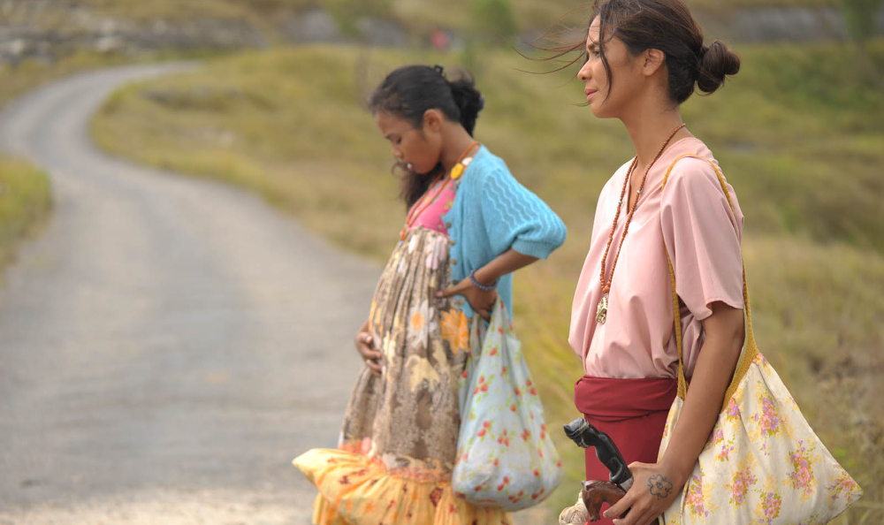
Marlina the Murderer in Four Acts

FIVE FLAVOURS FILMS
Five Flavours, both as the distribution label and film festival, is committed to present the diversity of contemporary Asian cinema – from small independent productions to mainstream hits. It showcases films from South-East, East and South Asia and aims to bring to Poland especially lesser known film industries such as the Philippines, Indonesia, Bhutan, Malaysia, Thailand. Five Flavours invites its viewers for a cinematic journey to Asia viewed from the perspective of contemporary filmmakers who comment on their countries and identities using a universal language of cinema.

CONTACT DETAILS
Emilia Skiba
emilia@piecsmakow.pl
Mobile, WhatsApp: +48 606 557 279

FIND US ONLINE
www.piecsmakow.pl (PL/EN)
www.instagram.com/piecsmakowff (EN)
www.twitter.com/Five_Flavours (EN)
www.facebook.com/piecsmakow (PL)

APOCALYPSE CHILD
The Philippines 2016, 95'
Release date in Poland: 6 October 2017
Release in Tagalog & English with Polish subtitles

SYNOPSIS
Crystal-clear waves, bright beaches, skin bathing in the sunshine, the sleepy atmosphere of the end of season. This is Baler, a place where 30 years ago Francis Ford Coppola spent a few months shooting "Apocalypse Now." Today, it is a paradise for surfers, including Ford – the association with the name of the director is not a coincidence. The man spends carefree days with his energetic, direct girlfriend. Then his old friend comes to visit, along with his stunningly beautiful fiancée.
The script written by a producer-director team, Mario Cornejo and Monster Jimenez, is a light portrait of four friends, filled with subtle humour, but also with existential questions. The breath-taking beauty of the scenery, the unassuming eroticism of the joined trips to the beach, and the lovely evenings are not everything – the aura of never-ending holidays will not protect the protagonists from taking responsibility for their lives and confronting their past. Thanks to the frames filled with distilled light, the natural acting, and the leisurely editing, the film evades overt literality. The melancholic beauty of the images is complemented by the atmospheric music of Armi Millare from the indie rock group Up Dharma Down. The result is an emotionally balanced, mature work, a powerful stimulus for the senses.

APOCALYPSE CHILD IN POLAND
The film premiered in Poland in November in 2016 at the 10 Five Flavours Film Festival with director Mario Cornejo and producer Monster Jimenez in attendance.

It was presented in the competition section New Asian Cinema and was named the Best Film by the festival's People's Jury who justified their verdict by saying: "The main award goes to 'Apocalypse Child' by Mario Cornejo For the affectionate portrayal of Filipino identity in its global, local, and individual dimensions, for a humorous, yet complex confrontation with the micro legacies of colonialism, and for its universal thematic and visual appeal."
"Apocalypse Child" is the first title to be released by Five Flavours, on 6 October, just a month ahead of the 11 edition of the festival (15-22 November, 2017).

CAST & CREW
Director: Mario Cornejo
Screenplay: Mario Cornejo, Monster Jimenez
Cast: Sid Lucero, Annicka Dolonius, RK Bagatsing, Ana Abad Santos, Gwen Zamora
Producers: Monster Jimenez, Aurora Oreta, Michelle Dinglasan-Tomacruz, Marti Magsanoc
Produced by: Arkeofilms
Cinematography: Ike Avellana
Music: Armi Millare
Editing: Lawrence S. Ang
Sound: Corinne De San Jose

MARIO CORNEJO
Film director and an award-winning advertising artist working for Film Experts, one of the biggest production companies in the Philippines. His debut comedy, "Big Time," was a smashing success awarded at Cinamalaya festival. He is also the author of a short documentary, "Stray Hearts," shown at Rotterdam IFF, and the producer of an award-winning documentary "Kano: An American and His Harem."
Filmography: 2005 Big Time, 2006 First Day High, 2008 Stray Hearts (short)
2016 Apocalypse Child

