October 22, 2018

Full Program of the 12th Five Flavours Asian Film Festival (November 14-21)
Five Flavours Asian Film Festival is a yearly review of the cinema of East, Southeast, and South Asia. For the 12th time, the Festival presents a meticulous selection of films from the region – auteur projects, avant-garde animations, classics from the film archives, local blockbusters, and Asian Film Awards-winning genre cinema.
The majority of the films will be screened in Poland for the first time. For five of them, the festival screening will be their European premiere. Asian filmmakers will visit the festival and join us for Q&A sessions, providing the titles presented with additional context.
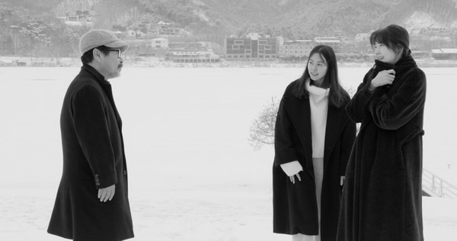
In Asian cinemas, the year 2018 is marked by a variety of auteur projects by renown directors, classic genre cinema, and blockbusters gaining momentum in world-wide box offices. At the same time, a new generation of filmmakers is on the rise – their films already gain visibility and receive awards at international festivals.
The program of this year's edition includes the most prominent Asian titles of the season, retrospectives summarizing the new directions of the film industry of the region, and archival classics. Among the films screened are "Killing," the new film by Shinya Tsukamoto, the Japanese master of auteur cinema, and "Hotel by the River," another very personal project by the director Hong Sang-soo. The program also includes the new films by three filmmakers who excel in using the conventions of genre cinema. In "Youth," Feng Xiaogang shows the Cultural Revolution from a new, fresh perspective. In "Birds Without Names," Kazuya Shiraishi uses the convention of a psychological drama to create a nuanced portrait of a romantic relationship, while his "The Blood of Wolves" is a daring gangster film based on a classic motif of two battling yakuza clans. In "Dukun," Dain Said combines the elements of a courtroom drama and a horror, creating a truly disturbing image of the relationship between power and black magic. The horror is also present in the series "Folklore" - a break-through production of HBO Asia, in which five renown Asian directors created an anthology of fear rooted in the folk tales of the region. Two episodes of the series will be screened at the Festival: "Folklore: Pob" by Pen-ek Ratanaruang, and "Folklor: Toyol" by Ho Yuhang. The high-budget films are best represented by Chinese blockbusters – "Operation Red Sea," directed by the master of action cinema, Dante Lama, and a historic "Brotherhood of Blades II: The Infernal Battlefield" by Lu Yang, a talented director of a new generation.
Five Flavours Film Festival is a unique opportunity to explore the vivid variety of Asian cinema – enjoy the insane imagination of radical filmmakers, discover Asian pop culture, discuss art, politics, and the challenges of modernity.
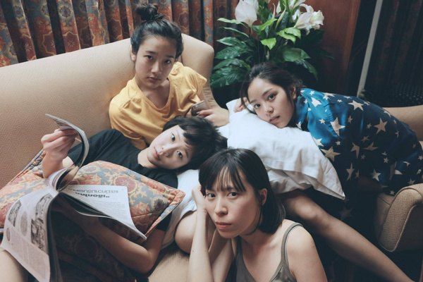
As usual, the main axis of the festival is the competition section presenting new auteur cinema from countries such as Taiwan, Singapore, Vietnam, the Phillipppines, Hong Kong, Malaysia, Japan, China, and Thailand. The Q&A sessions with festival guest after the screenings are a great opportunity to discuss values, cinephile fascinations, and contemporary culture. New Asian Cinema is a meeting space for the avant-garde aesthetics, controversial statements, formal experiments, and fresh voices commenting on the history of Asia and its current reality. The eleven titles of the section compete for the honorary Grand Prix of the 12th Five Flavours AFF.
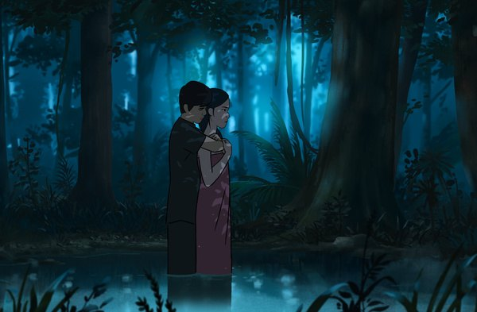
One of the main sections this year showcases Asian animations – avant-garde, independent animated films, which break conventions and push the limits of genres. The program includes, among others, this year's winner of Annecy IFF, "Funan" by Denis Do, the experimental "Violence Voyager" by Ujicha, and the dystopian "Dahufa" by Busifan.
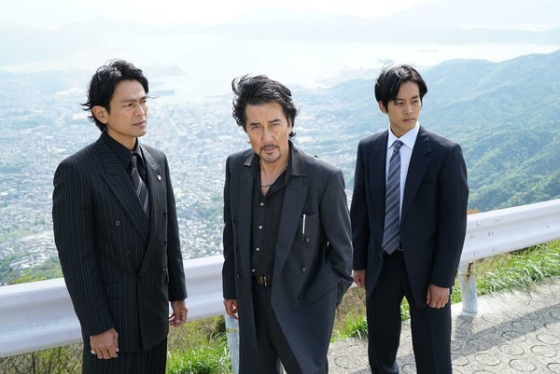
Special Screenings is a section devoted to the films especially important for Asian cinema, and new productions by filmmakers well-know to the Festival audiences. The lineup includes "Hotel by the River," one of the newest films by the renown Korean director Hong Sang-soo, the radical "Killing" by Shinya Tsukamoto, a Chinese box-office hit "Operation Red Sea" by Dante Lam, and the mobster tale by Kazuya Shiraishi - "The Blood of Wolves."
For the second time, Five Flavours teams up with Asian Film Awards Academy, the institution supporting the promotion of high quality commercial cinema from Asia. The result of this collaboration is a section made up of stunning genre cinema and the newest hits by renown filmmakers, nominated and awarded at this years Asian Film Awards gala. The highlights of the section include the period action film "Brotherhood of Blades II: The Infernal Battlefield" by Lu Yang, the political thriller "1987: When The Day Comes," and Wilson Yip's "Paradox."
The 12th edition of the festival opens with "Youth" - a spectacular bittersweet story directed by Feng Xiaogang, one of the leading Chinese filmmakers. The closing film is the Taiwanese animation "On Happiness Road" by Sung Hsin-yin, in which the director explores the generational experience of people growing up in Taiwan during the turbulent political changes of the late 1980s
The screenings are accompanied by a number of Q&A sessions with filmmakers and experts, and Asian Academy's debates and lectures, which outline and deepen the themes presented in the films.
The 12th Five Flavours is the fifth edition of the Festival with its visual identification based on the Far-Eastern lunar calendar and zodiac signs. 2018 is the Year of the Earth Dog.
The program of the 12th Five Flavours includes 37 feature films. Six selected titles will also be shown in Wrocław, in New Horizons cinema, between November 23 and 25.
All films are presented in their original languages, with English and Polish subtitles. The full program of the festival, with descriptions of all movies in English, is available at the festival website: piecsmakow.pl

see the full program

screening schedule

Tickets
Regular ticket: 22 PLN
Tickets for screenings on Monday and on weekdays before 5 PM: 17 PLN
Opening Gala: 30 PLN
Animations Night: Quiet Nightmares: 55 PLN
Tickets for all screenings are available at piecsmakow.pl and via Going. They can also be purchased in the box offices of the cinema where the screening takes place.
Kino Muranów – ph.: 22 635 30 78, muranow.gutekfilm.pl
Kinoteka – ph.: 22 551 70 70, kinoteka.pl
The seats in both cinemas are unnumbered.

buy tickets

Organizer: Fundacja Sztuki Arteria
Co-financing: Warsaw City Council, Ministry of Culture and National Heritage, Asian Film Awards Academy, CreateHK, HK Film Development Fund
Sponsors: Mitsubishi, Asia Travel
Partners: Asian Fim Awards Academy, Taiwan Film Institute, Kino Muranów, Kinoteka, Culture.pl, Asian Film Academy, MSN, MAIP, Tajfuny
Media partners: Filmweb, Kino, Ekrany, CJG24, AMS, Vogue Polska, Aktivist, Fiszki Polityki, Pismo., NN6T, Going, Warsawholic, Enter the Room. Eastern Kicks, Asian Movie Pulse, Cinema Escapist, Asia in Cinema, Kultura Liberalna, Contemporary Lynx, Warsaw in Your Pocket

More at piecsmakow.pl
Follow us on Facebook, Twitter, and Instagram

