August 28, 2018
Newsletter

Asian Animations at the 12th Five Flavours Asian Film Festival

The program of the 12th Five Flavours Asian Film Festival includes a long-awaited section devoted to Asian animations. It’s time to reveal the first titles.
We leave the zone of the safe, market-calculated Japanese anime, and sail towards the uncharted territory – animated films from other Asian countries and experimental Japanese productions. The Chinese cinema prides itself on the traditions of animation going back to 1940s, and its 1960s golden era, but in other parts of South-East Asia, animated films are still a rarity.
The lack of visual restrictions and a production model very different from live-action films allows the creators of Asian animations to unleash their imagination and creativity and pushes them in a variety of new directions, broadening the cinematic language.
Let’s get ready for a crazy journey through new territories! Today we reveal titles representing China, Taiwan, and Japan:
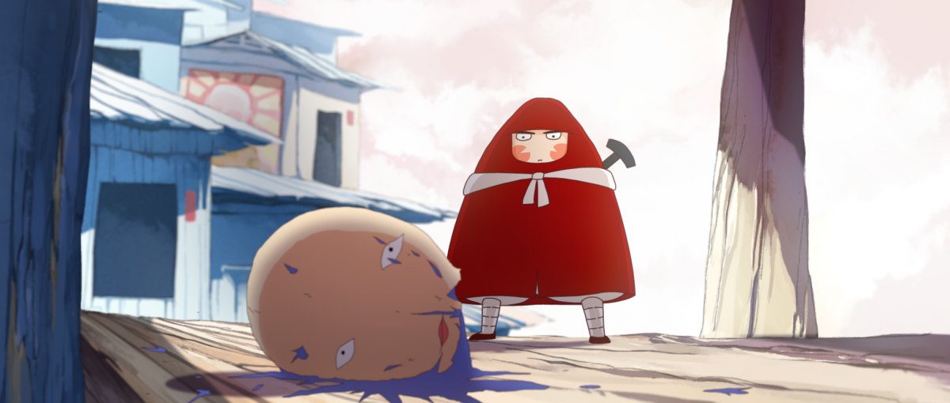
Dahufa (dir. Busifan, China 2017)
Don’t let the appearances fool you – kids are not the target audience of this animation. The level of violence shown on the screen borders on gore. The main character, the royal warrior Dahufa, embarks on a journey to find a stubborn prince. His search brings him to Peanut Town – a dystopian land ruled by a despot. This independent production pushes Chinese animation to new, unknown waters, but at the same it is heavily inspired by the 1960s and the achievements of Shanghai Animation Film Studio.
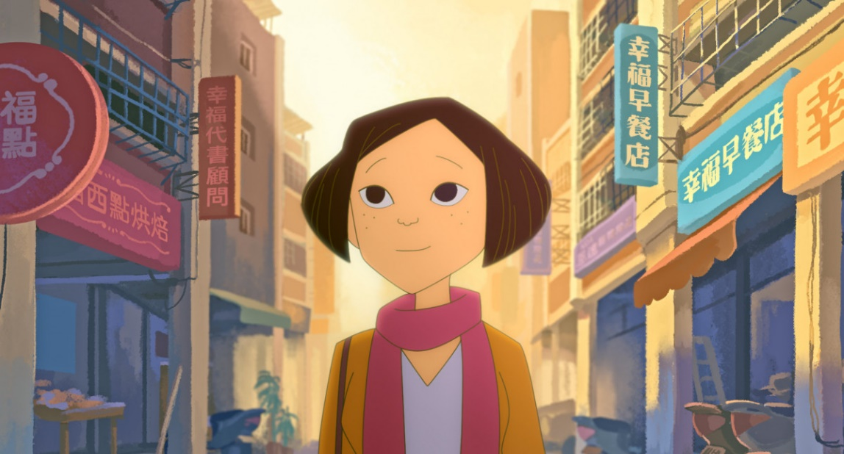
On Happiness Road (dir. Sung Hsin-yin, Taiwan 2018)
Adolescence and a search for identity shown in a series of retrospects from the story of a girl coming back to Taipei to escape her failed marriage and her life in the US. The sun-filled frames of the animation correspond with a script filled with humor, but everything about this story turns out to be bitter-sweet. Coming back home does not always mean finding happiness.
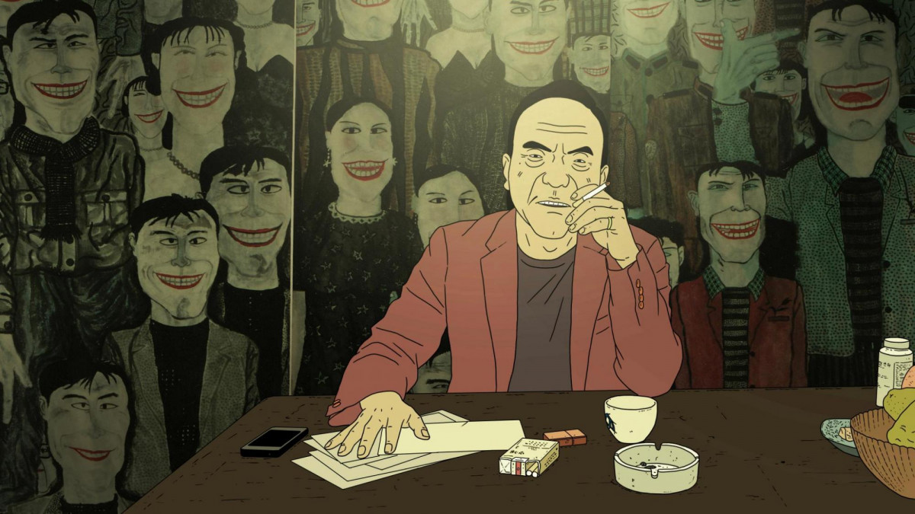
Have a Nice Day (dir. Liu Jian, China 2017)
A story from the outskirts of a metropolis in South China, where life centers around an internet cafe, a dingy motel, and a few small bars. The deserted streets, filled with old signs and closed shops, are the setting of a chaotic chase after a backpack filled with money. The Tarantinoesque atmosphere is combined with references to contemporary Chinese politics.
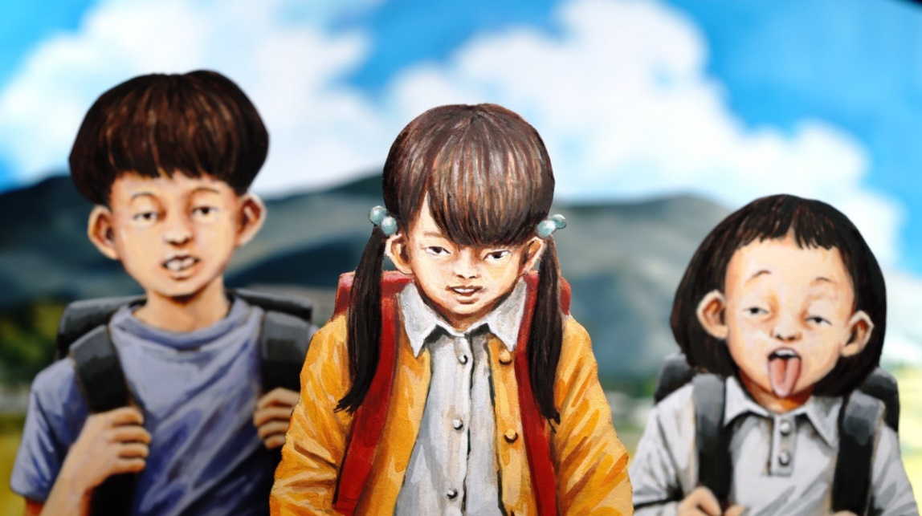
Violence Voyager (dir. Ujicha, Japan 2018)
Two friends from elementary school, an amusement park hidden in the forest, a mad scientist, and body modifications. Sounds like a classic macabre tale by the Grimm brothers, but this time, in its Japanese interpretation, the wolf is replaced by evil cyborgs. The animation, made using paper-cut figures, proves that in Japanese animations, the technique can keep up with the unfettered imagination.

Read more >
Passes for the 12th Five Flavours AFF are already available. They come in two types – the regular pass and the Master Pass, which includes free entrance to all Five Flavours events and all concerts of the Radio Asia Festival (December 6-9, Warsaw).
Buy a Festival Pass >

12th Five Flavours Asian Film Festival – Warsaw, November 14-21
The full program will be announced in mid-October.
Organized by: Arteria Art Foundation
Partners: Warsaw City Council, Polish Ministry of Culture and National Heritage, Asian Film Awards Academy
More at www.piecsmakow.pl
Follow us on Facebook, Twitter, and Instagram, read blog.piecsmakow.pl.

