Press release
28 June 2017

First details of 11th Five Flavours Asian Film Festival programme

The wisdom of the Buddhist priestess, Japanese erotic films and avant-garde treasures of film archives: Five Flavours reveals first details of this year’s diverse and exciting programme.

The world of Asian cinema is growing and expanding rapidly: artists from the smallest regions of the continent are finding their way to international festival audiences, independent filmmakers unite across borders to speak out about the most difficult subjects, the producers of local blockbusters are more and more successful in competing with global giants. Five Flavours Film Festival for the 11th time invites everyone to discover and experience this bustling universe. The viewers will have a chance to encounter the wildest productions of Asian pop culture, to admire contemplative film poems and to engage in discussions about art, politics and challenges of the modern world.

Below we present the main sections of the 11th edition of the Festival.
The Festival Passes will be available from August 1st!

FOCUS: BHUTAN
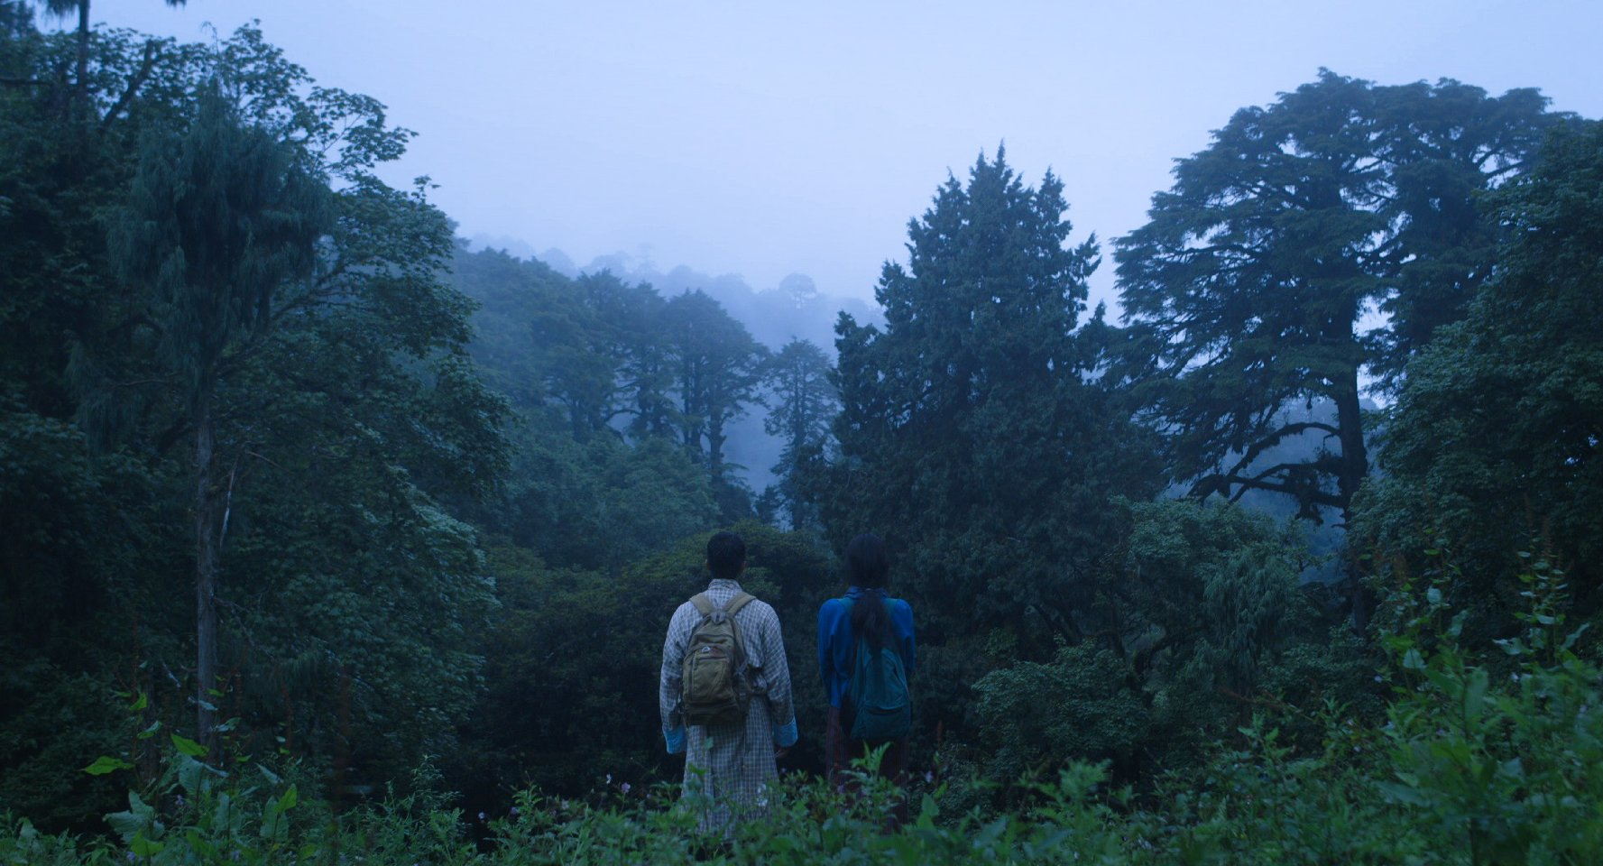
Honeygiver Among the Dogs, dir. Dechen Roder, Bhutan 2016
Located in the eastern Himalayas, the Kingdom of Bhutan has less than a million inhabitants and until recently was very cautious about the influx of modern technologies - only in 1999 the government allowed a television broadcasting. In the next few years film production became more and more regular and developed.
Today, Bhutan's cinema can already boast of talented authors who successfully combine their local traditions and background of Buddhist philosophy with the universal language of film. One of them is Dechen Roder, a documentary filmmaker and director, whose "Honeygiver Among the Dogs," featured in this year's Berlinale programme, has delighted critics with the combination of an artistic vibe with the poetics of noir cinema. Apart from this intriguing work, the section will feature a set of films reflecting the evolution of the Bhutanese cinema, allowing the audience to explore inaccessible areas of this mysterious country.

ROMAN PORNO
Dawn of the Felines, dir. Kazuya Shiraishi, Japan 2017
The Japanese erotic cinema, the so-called pinku eiga, was thriving at the turn of the 1970s and 1980s when major labels underwent a severe financial crisis. The niche, fast-produced flicks have become a shelter for the most avant-garde filmmakers, who have taken the opportunity to experiment and explore the boundaries of cinema, often smuggling political content between the sex scenes. Nikkatsu studio played a special role in this field with its Roman Porno series, highlighting the artistic values of erotic genre and giving the directors unlimited freedom in choosing their topics.
In 2016 Nikkatsu announced a reactivation of the cult production label, inviting the most extreme Japanese filmmakers and aiming at a new generation of audience with more and more female viewers enjoying the genre. The first film of the new series was Sion Sono's "Antiporno", screened at Five Flavours last year. The programme of the 11th edition will include two new works by Akihiko Shiota and Kazuya Shiraishi, as well as two classic titles from the original Roman Porno archives.

ANN HUI’S RETROSPECTIVE
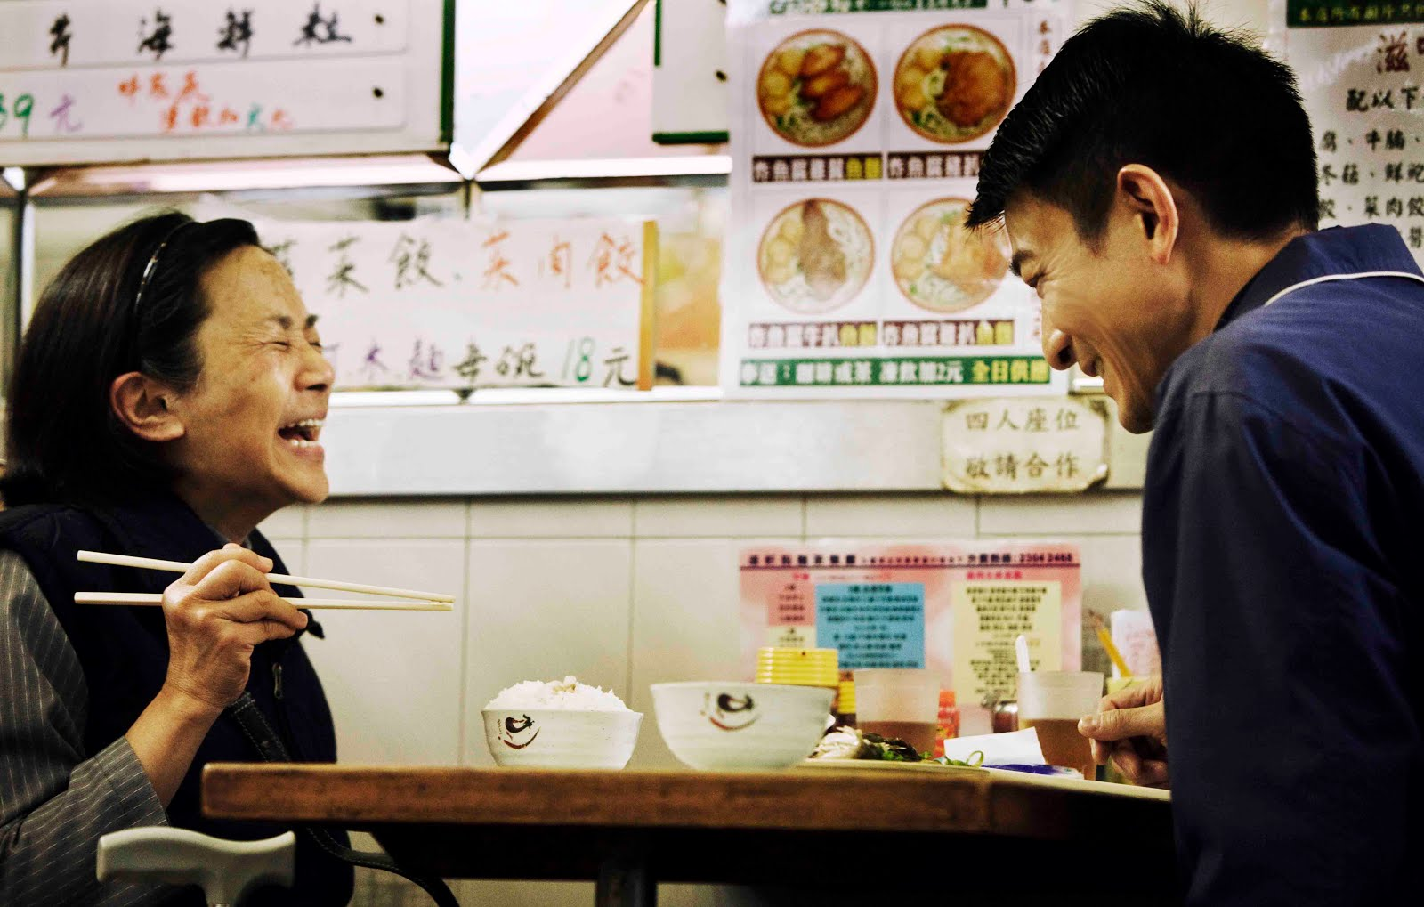
A Simple Life, dir. Ann Hui, Hong Kong 2013
This year's directorial retrospective will be dedicated to one of most prominent figures of Hong Kong's new wave and at the same time one of the most influential people in contemporary Hong Kong cinema. Ann Hui celebrated her 70th birthday this year, remaining an active and creative artist. Actress, producer and screenwriter has more than 30 titles in her directorial output, ranging from social dramas – as the breakthrough "The Boat People" (1981) about the Vietnamese refugees – through ghost comedies ("The Spooky Bunch" 1980) and martial arts ("The Romance of Book and Sword", 1987) to historical epics ("Golden Age", 2014). Her newest super-production, "Our Time Will Come," released this summer is a stylish melodrama set in the days of the Japanese occupation of Hong Kong. "A Simple Life" by Ann Hui has opened the 7th edition of Five Flavours.

THE COMPETITION AND SPECIAL SCREENINGS
As every year, the highlight of the Five Flavours programme will be the New Asia Cinema competition section, presenting fresh voices and outstanding productions that address current issues and broaden the boundaries of film imagination. Creative, widely discussed films from Indonesia, Taiwan, Hong Kong, Bangladesh or Japan will compete for the main prize, awarded by the People's Jury – a group of cinema enthusiasts selected via a competition – and for the NETPAC Award.
Special screenings will feature prominent filmmakers and the most talked about premieres of the past year. Among the focal points of the section is a restored masterpiece of the Japanese avant-garde, "Tokyo Drifter" (1966) directed by Seijun Suzuki who died on 13rd February this year.
Tokyo Drifter, dir. Seijun Suzuki 1966

For the first time Five Flavours will feature a special programme curated in cooperation with the Asian Film Awards Academy which aims to promote Asian cinema and honour outstanding filmmakers. The section will include titles nominated and awarded at this year's Asian Film Awards to reflect the diversity of contemporary Asian cinema.
The programme will be complemented by introductory talks, Asian Academy's lectures, and Q&As with filmmakers.

FESTIVAL ESSENTIALS
For those coming to the Festival from out of Warsaw, we are preparing a special hospitality offer. Details will be revealed at the beginning of July.
If you have any questions, contact us at hospitality@piecsmakow.pl.
Festival Passes will be available from August 1st.
The 11th edition of Five Flavours will take place on November 15-22 in Warsaw.

Organizer: Arteria Art Foundation
Partners: City of Warsaw, The Ministry of Culture and National Heritage, Polish Film Institute, Japan Foundation, Hong Kong Economic and Trade Office, Asian Film Awards Academy

Contact:
Emilia Skiba, emilia@piecsmakow.pl, +48 606 557 279
www.piecsmakow.pl
Follow us on Facebook, Twitter and Instagram

