The 11th edition of Five Flavours Asian Film Festival will be held on November 15 – 22 in Warsaw, in Muranów and Kinoteka cinemas and in the Museum of Modern Art. The program includes over 40 feature films and nine short films. Eight selected pictures will also be screened in Wrocław, in New Horizons Cinema on November 17 – 23.
The majority of the films will be shown in Poland for the first time, and two pictures from Bhutan will have their international premieres at the Festival. We will also host a number of guests from Asia.
The 2017 edition continues the visual identification based on the Lunar Calendar and zodiac signs. Thus, 2017 is the year of the Fire Rooster.
The festival screens films from South East, East and South Asia and is the only film event in Poland focused primarily on Asian Cinema. For eleven consecutive years, Five Flavours has brought to Poland premiere screenings of the latest and most appealing productions, classics and retrospectives of renowned Asian filmmakers. Previous editions saw the pioneering programs of cinema from Vietnam, Thailand, Taiwan, Malaysia, Singapore, Hong Kong.
The world of Asian cinema is growing and expanding rapidly – artists from the smallest regions of the continent are finding their way to international festival audiences, independent filmmakers unite across borders to speak out about the most difficult subjects, the producers of local blockbusters are more and more successful in competing with global giants. Five Flavours Film Festival invites everyone to discover and experience this bustling universe. The viewers will have a chance to encounter the wildest productions of Asian pop culture, admire contemplative film poems and engage in discussions about art, politics and challenges of the modern world.
The program of the Festival is comprised mostly of titles unknown in Poland, unavailable in regular distribution. The wide selection includes auteur cinema, as well as high-quality genre cinema; daring works of independent filmmakers and commercial blockbusters which hold a special place in the cinematic landscape of Asia. The previous editions of Five Flavours included pioneering retrospectives of cinema from Vietnam, Thailand, Taiwan, Malaysia, Singapore, and Hong Kong.
The screenings are accompanied by a diverse program of additional events, including meetings with directors and other film guests, critics or experts, debates, workshops.

Like every year, the highlight of Five Flavours program is the New Asia Cinema competition section, presenting fresh voices and outstanding productions that address current issues and broaden the boundaries of film imagination. Films from Indonesia, Taiwan, Hong Kong, Bangladesh or Japan will compete for the Grand Prix of the Festival.
The program includes a section devoted to the cinema of the most mysterious Asian countries, the Himalayan Bhutan, and the retrospective of a key new wave filmmaker, one of the most important people in the Hong Kong film industry, Ann Hui. The program includes also a fair share of genre cinema, featured in the section devoted to the avant-garde erotic productions from Japan, and in the Asian Cinerama section, a review of Asian Film Awards winners and nominees. Also devoted to the genre films is the Restored Classics section.
OPENING AND CLOSING FILMS
On November 15, the 11th edition of Five Flavours will begin with the screening of "Our Time Will Come," the new directed by Ann Hui, whose retrospective is a part of this year’s program. The film portrays the local resistance movement in the 1940s, and its relation to modern Hong Kong touches upon one of the most important themes in the director's works – the question of the identity of an individual in a wide, sociopolitical context.
The festival will close with a film directed by the most internationally renown Bhutanese filmmaker and a Buddhist monk, Khyentse Norbu. "Hema Hema: Sing Me a Song While I Wait" ("Hema Hema" means "a long time ago") is a visually stunning, avant-garde drama, combining the traditions of a Shakespearean tragedy with Buddhist tales of death and desire.

COMPETITION SECTION: NEW ASIAN CINEMA
Like every year, the highlight of Five Flavours program is the New Asia Cinema competition section, presenting fresh voices and outstanding productions that address current issues and broaden the boundaries of film imagination. Creative, widely discussed films from Indonesia, Taiwan, Hong Kong, Bangladesh, Malaysia or Japan will compete for the Grand Prix of the Festival.
The winner of the main award (3500 EUR), founded by the director of Polish Film Institute, will be chosen by People's Jury – a group of cinema enthusiasts and Asian cultures fans. NETPAC, the Network for the Promotion of Asian Cinema will also award one of the competition films.

FOCUS: BHUTAN
Contemporary Bhutanese cinema invites the audiences to one of the most inaccessible parts of the world, combining unique local artistic traditions and Buddhist philosophy with an intriguing, ambitious form and interesting generic conventions. The retrospective at Five Flavours is a rare opportunity to discover the culture of the Himalayan kingdom – both its traditional and modern side.

ROMAN PORNO
The Japanese erotic cinema, the so-called pinku eiga, was thriving at the turn of the 1970s and 1980s when major labels underwent a severe financial crisis. The niche, fast-produced flicks have become a shelter for the most avant-garde filmmakers, who have taken the opportunity to experiment and explore the boundaries of cinema, often smuggling political content in-between the sex scenes. The Nikkatsu studio played a special role in this field with its Roman Porno series, highlighting the artistic values of erotic genre and giving the directors unlimited freedom in choosing their topics. In 2016 Nikkatsu announced a reactivation of the cult production label, inviting the most extreme Japanese filmmakers and aiming at a new generation of audience with more and more female viewers enjoying the genre.
PORTRAIT: ANN HUI
A retrospective of a prominent author of the Hong Kong New Wave and the most influential female director in modern Hong Kong cinema. Hui inspects the everyday life and ordinary heroes, using their perspective to show the complex history of Hong Kong, the crossroads between the traditional Chinese culture the reality of a British colony. Memories and flashbacks are used to speak about cultural identity, as well as history and politics shaping it in an individual and social dimension.

ASIAN CINERAMA
For the first time, Five Flavours features a special program curated in collaboration with Asian Film Awards Academy, an institution created by festivals in Busan, Hong Kong, and Tokyo to promote Asian cinema year round, and to support young filmmakers. Asian Cinerama section introduces six major films from the Asian Film Awards to the Polish audience.

RESTORED CLASSICS
Exploring the roots of modern aesthetics of Asian cinema, Five Flavours rediscovers the outstanding achievements of the past decades. It is a unique opportunity to dig into the lesser-known history of cinema and to see restored classics on a big screen. One of the focal points of the section is a screening of a restored masterpiece of the Japanese avant-garde, "Tokyo Drifter" (1966) directed by Seijun Suzuki who died on February 13 of this year.

SPECIAL SCREENINGS
Special Screenings section showcases the works of prominent filmmakers and the most talked-about premieres of the past year, including new films by directors well-known to the Festival’s audience – Naoko Ogigami and Sion Sono, and debutantes at the beginning of their film careers – participants of the Hong Kong Fresh Wave program, which supports young talents and the development of independent cinema.

FILM MARATHONS
During the Festival, we will hold two thematic film marathons. One of them, the Corponight, is dedicated to all-kinds-of-business people. The program includes three films – a crime story from Hong Kong, a melodrama from Japan, and a horror from Thailand – which employ a variety of genre conventions for a metaphorical analysis of the culture of advertising, marketing, and estate developers.
The second special evening s the night with Baahubali. The program includes two parts of the saga devoted to the hero – the biggest success in the history of Tollywood, the cinema of Southern India. The saga became a social phenomenon, gathering a cult following similar to the global "Star Wars" or "Lord of the Rings" craze. The stunning visual effects and the emotional plot amazed audiences all over the world, from China to the US.
The festival is traditionally preceded by Asian Horror Night held in Muranów cinema on October 28. The program includes three horror films: "Satan’s Slaves" from Indonesia, "The Promise" from Thailand, and "Kotoko" from Japan.

ASIAN ACADEMY AND FESTIVAL MEETINGS
A cycle of lectures deepening the understanding of festival films – an opportunity to discover the sociopolitical contexts, aesthetic traditions, the relationship between cinema, everyday life and the current events in Asia. This year, the festival meetings include lectures devoted to both political and aesthetic topics. The invited experts will talk about the culture of Bhutan and Indonesia, political and economic entanglements of modern Hong Kong, the influence of traditional Chinese aesthetics on the modern cinema, and the influence of the recently deceased Japanese master, Seijun Suzuki, on the gangster film genre.
The lectures will be held in the seminar room in the Museum of Modern Art at Pańska street.
Despite the Q&A sessions with festival guests, which take place after the screenings of their films, the program also includes special debates. During the meeting with director Dechen Roden, we will learn more about the film industry in Bhutan. Hong Kong producer Roger Lee will talk about his cooperation with Ann Hui, whose retrospective is a part of this year’s program. A young Polish director, Weronika Milczewska, will talk about making a documentary film in India. At the meeting with traveler Renata Koper, we will listen to Bhutanese tales and legends.

EXHIBITION – DANWEN XING
A PERSONAL DIARY: THE CHINESE AVANT-GARDE 1993–2003
Part of the Festival program is comprised of events connected with the Museum of Modern Art exhibition of the works of a Chinese photographer documenting the life of a Chinese Bohemia of the 1990s. Danwen Xing portraits the generation of artists born during the Cultural Revolution, interested in visual arts, experimental theater, new music scene, and film. One of those filmmakers was Yang Chao, the director of "Crosscurrent" shown at this year’s Five Flavours, and the guest of the Festival.
During the Festival, the audiences can participate in guided tours led by the curator, Magda Lipska, attend a lecture devoted to the Chinese avant-garde movement, and the screenings of two documentary films portraying the life of independent artists ("Diary: Snow, November 21, 1998", dir. Wu Wengwuang, China 1988, "Bumming in Beijing", dir. Wu Wengwuang, China 1990).

VOD
A virtual edition of Five Flavours Film Festival will be available online in at VoD.pl on November 10 – 30. The program includes films from New Asian Cinema competition, some of the hits from last year’s edition of the festival (including "Apocalypse Child" directed by Mario Cornejo, winner of the Grand Prix), short features from the Hong Kong Fresh Wave cycle and other selected festival titles.

TICKETS
Tickets for screenings at Muranów and Kinoteka cinemas (except special events and marathons): 20 PLN
Events in the Museum of Modern Art: free entrance
Tickets for screenings on Monday and every day before 5 PM: 15 PLN
Tickets for all the screenings are available online at piecsmakow.pl and at the Going website.
Tickets are also available in the ticket office of the cinema where the screening is held: Muranów cinema – 22 635 30 78, muranow.gutekfilm.pl, Kinoteka – 22 551 70 70, kinoteka.pl.

All films are screened in original language versions with English and Polish subtitles.

RADIO ASIA FESTIVAL
17-21 December 2017
Concerts, workshops, radio dramas and an Asian jam-session. This year marks the third season of Radio Asia – concerts devoted to niche Asian music. The event will take the form of a five-day festival held on December 17-21.
Like every year, we present unique artists, who never cease to explore and experiment, merging the traditional and the local with their personal, modern music vision.
The Festival is comprised of five concerts by Asian artists, day-long music workshops, a radio drama devoted to the most interesting phenomena combining the traditional and contemporary scene of the Far East, and an Asian jam-session – an improvised concert, in which everyone can perform along the festival musicians.
Performing on the first day is Taro Yasuno – music constructor, the Japanese creator of unconventional installation, whose synthetic fingers play minimalist compositions on a set of wind instruments. In the following days we will hear two bands from Indonesia. The first one, Senyawa, is an experimental duet filled with uncontrollable energy and stage expression, and avant-garde form rooted in primordial rituals. The other band, Kande, is a thrilling fusion if Indonesian folklore, Sufi mysticism, rock vigor and jazz improvisation. Performing on the fourth day is Mouth & Hand Studio from South Korea, playing the traditional pansori opera in an innovative form and auteur arrangements, offering a hypnotic journey from minimalism to a sound avalanche. The Festival ends with the concert of a phenomenal singer, Shapla Salique, combining the music of Bauls with jazz and soul vibrations.
The concerts are held in TR Warszawa, Mózg Powszechny, and Teatr Syrena.
Partners: TR Warszawa, Teatr Syrena, Mózg Powszechny, Ruch Muzyczny
Media: CoJestGrane, Aktivist, Glissando, Etnosystem, UwolnijMuzykę!
The project is financially supported by Warsaw City Council.

Festival passes and tickets
Radio Asia Pass: 120 PLN. Tickets: 35 PLN (Taro Yasuno), 50 PLN (Senyawa, Kande, Mouth & Hand Studio, Shapla Salique)
The tickets for the concerts are available at radioazja.pl, eventim.pl and in the ticket offices of TR Warszawa i Teatr Syrena.

Contact
Anna Mamińska, anna@piecsmakow.pl, 504 301 284
FESTIVAL GUESTS
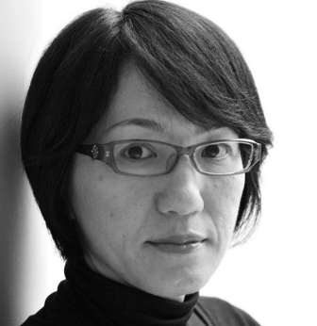
Naoko OGIGAMI
director of "Close-Knit" [Special Screenings]
present: 18 XI
Born in 1972 in the Chiba Prefecture. In 1994, she left for the US where she studied directing at the University of South California. Her sweet and melancholic films, with a characteristic visual style, are enormously popular among the audiences, often appearing at international festivals. "Glasses" and "Rent-a-cat" were shown in the "Japanese Female Directors" retrospective at 9th Five Flavours.
This year, she comes back with her new film "Close-Knit," taking up the subject of transsexual people in the Japanese society, made in a convention of a charming, bitter-sweet family film. The movie received the Teddy Award at this year’s Berlinale.

Mouly SURYA
director of "Marlina The Murderer in Four Acts"
[New Asian Cinema; in theatrical distribution in March 2018]
present: 19-22 XI
Born in Jakarta, considered to be one of the most important artists among the young Indonesian filmmakers. She studied media and literature in Indonesia and directing in Australia. Her debut film brought her the Best Director award at the film festival in Jakarta, her second feature was shown at Sundance, in Rotterdam, and in Karlove Vary. "Marlina" is her third production and the only film from Southeast Asia shown this year in Cannes.

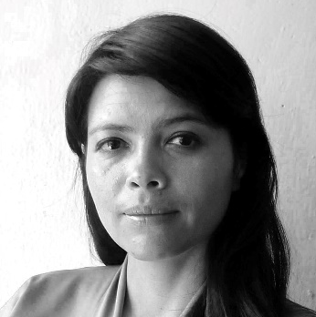
Dechen RODER
director of "Honeygiver among the Dogs"
[New Asian Cinema / Focus: Bhutan; in theatrical distribution in February 2018]
present: 15-23 XI
Director born in Bhutan in 1980. Since 2004, she has been directing short films and documentaries, broadcast in Bhutanese public television. Her short features were shown at film festivals in Hong Kong, Brussels, Berlin, Melbourne, and Palm Springs. She is a co-founder of the first Bhutanese documentary and short film festival Beskop Tshechu. "Honeygiver Among the Dogs" (2016) is her feature debut.
Pema TSHERING
producer of "Golden Cousin" and "In a Defiled World" [Focus: Bhutan]
present: 15-22 XI
Born in 1969. producer, cinematographer, actor, director of Thuktro Productions studio, active in the film industry. He studied linguistics and cultural studies in Bhutan and cinematography in India. Between 2015 and 2017, he was on the board of Bhutan Film Association.

Lhaki DOLMA
actress "In a Defiled World" [Focus: Bhutan]
present: 15-22 XI
Actress, laureate of numerous acting awards, one of the most important people in the Bhutan film industry. Screenwriter, director, producer and social activist working for women and children’s rights.

Pema TSHERING
director of "In the Realm of Gods" [Focus: Bhutan]
present: 15-23 XI
Director of the short feature "In the Realm of Gods," visual artist using traditional and modern graphic techniques, author of paintings and comic books. His works were shown at individual and collective exhibitions in Bhutan and abroad, including in Taiwan, Japan, Bangladesh, Thailand and the US.

Heiward MAK
producer of "Mad World" [New Asian Cinema / Asian Cinerama]
present: 17-23 XI
Born in 1984, studied design at Hong Kong University of Science and Technology, and media studies at Hong Kong University. She worked as a screenwriter, editor, and assistant director. Her first short feature was awarded at short film festivals in Hong Kong and Taiwan. She worked with Pang Ho-cheung writing the script for "Love in a Puff" (2009), one of the biggest hits of Hong Kong box office, which has already had two sequels and was named the best script at Hong Kong Film Awards.
She directed six features, made music videos and commercials. "Mad World" is her debut as a producer. The film premiered at Toronto FF, received a number of nominations and awards (including at festivals in Osaka, Hong Kong, Golden Horse Awards in Taiwan and Hong Kong Film Awards).
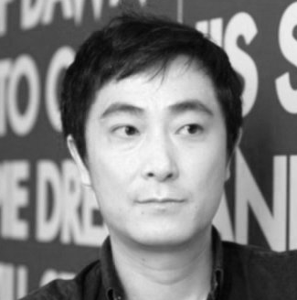
Katsuya TOMITA
director of "Bangkok Nites" [New Asian Cinema]
present: 19-22 XI
Born in 1972, has been directing since 1996. To make his feature debut, he worked at a construction site and drove a truck. He used award he received for the film to make his subsequent projects. His two latest features premiered in Locarno. He is one of the most original independent Japanese filmmakers, and lives in turns in japan and in Thailand. He is interested in migration and the search for individual identity.

Daisuke MIYAZAKI
director of "Yamato (California)" New Asian Cinema]
present: 18-23 XI
Born in 1980 in Yokohama, studied at Waseda University. He worked as production assistant and assistant director for the films of Leos Carax and Kiyoshi Kurosawa. He also wrote film scripts. His debut feature, "End of the Night," was praised by critics and audiences. In 2015, he took part in the Berlinale Talents project. He named his production company after Jerzy Skolimowski’s "Deep End."

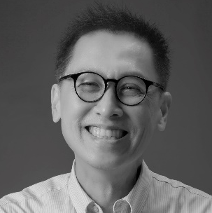
Roger LEE
producer [Portrait: Ann Hui]
present: 14-18 XI
He loved films since his Hong Kong school years. As a producer, he worked with the director Ann Hui three times – with "Summer Snow" (Best Actress award for Josephine Siao at Berlin IFF in 1995), "A Simple Life" (Best Actress award for Deanie Ip at Venice IFF in 2011), and "Our Time Will Come." The script for "A Simple Life" was based on the true story of his maid, Taojie, who worked for four generations of the Lee family for almost 60 years.

LE Bình Giang
director of "KFC" [New Asian Cinema]
present: 17-23 XI
Born in 1990 in Vietnam, director and screenwriter. He studied at the School of Cinema and Theater in Ho Chi Minh, but did not graduate – his final film project rejected for being too brutal. Le continued to work on his project and found sponsors thanks to the Film of the Future award he received at the Vietnamese Autumn Meeting 2013. As a result, his film "KFC" was selected for festivals in Rotterdam, Copenhagen, Buenos Aires, New York, Taipei.
HO Yuhang
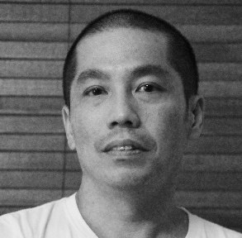
director of "Mrs K" [New Asian Cinema]
present: 16-21 XI
Born in 1971 in Petaling Jaya, studied film engineering at the University of Iowa. After returning to Malaysia, he worked as a producer of commercials and TV productions. He directed several independent short features, features and documentaries, praised by critics and awarded at various festivals, including Nantes, Rotterdam and Locarno.
His "Rain Dogs", the first Malaysian film shown in the competition at Venice IFF, was shown in the "Focus: Malaysia" section of the 6th Five Flavours.

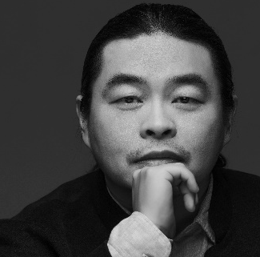
YANG Chao
director of "Crosscurrent" [Asian Cinerama]
present: 15-20 XI
Born in 1974, screenwriter and director, graduate of Beijing Film Academy, member of the Sixth Generation of Chinese filmmakers. His graduate short feature won a Cinéfondation award at Cannes IFF in 2001. His debut feature, "Passages," also premiered in Cannes and received a Special Mention. Making "Crosscurrent" took him almost 10 years.
The concept for the film was created in cooperation with cinematographer Mark Lee Ping-bing (known from Wong Kar-wai’s "In the Mood for Love," and Hou Hsiao-hsien’s "The Assassin"). The film brought him a Silver Bear at this year’s Berlinale.

Weronika MLICZEWSKA
director of "Long Way" [Special Screenings]
Anthropologist, director, photographer. She studied Cultural Studies at the University of Warsaw, directing and anthropology at Goldsmiths, University of London, photography at the Academy of Photography, and film at UCLA Extensions in Los Angeles. For over 10 years, she has been focusing on spiritual topics, translating them to the language of film. She made her projects in Central and South America, the Himalayas, South Africa, Japan, Jamaica, and beyond the Arctic Circle.

Festival guests also include young filmmakers from Hong Kong, whose productions are screened as part of the Fresh Wave project: directors Michelle Hung and Ashley Cheung and cinematographer Eric Tsang.

Jury NETPAC
present: 15-22 XI
NETPAC is an international non-profit organization devoted to the promotion of Asian cinema. During the Festival, the jury will gran an honorary award (NETPAC Award for Best Asian Film) to the best Asian film in the program.
The Jury is comprised of:

Sonali Joshi
Curator, expert in independent Asian cinema and audiovisual translation. Head of a London distribution company Day for Night. She has a PhD in film studies and lectures at British universities. Currently she is working with Indian Dharmasala International Film Festival, and curating a film program in Great Britain – "India at 70," devoted to the division of British India in 1947. She is also working on the 2018 Aperture: Asia & Pacific Film Festival.

Siddiq Barmak
Director, screenwriter, documentary filmmaker, producer. Born in Afghanistan in 1962. He studied directing in Moscow. His feature debut, "Osama" (2003), received awards in Cannes and Busan, and a Golden Globe for the best foreign language film. His documentaries include "The Disaster of Withering" (1988), "Narration of Victory" (1991), and "Invasion File" (1997). he is the head of a production company Barmak Films.

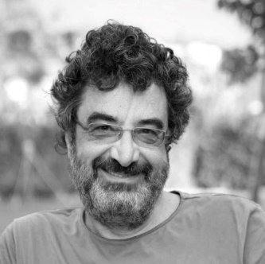
Cüneyt Cebenoyan
Film critic and actor. Born in Ankara in 1960. He set up a film club at the Boğaziçi University in Istanbul and made short features. Currently he is writing for the daily "Birgün" and has his own program devoted to films in Acik radio. As a film critic, he is the member of FIPRESCI and NETPAC. He starred in films such as "Hayatboyu" (Lifelong, 2013), "Dar Elbise" (Tight Dress, 2016), the series "Çıplak Gerçek" (Naked Truth, 2014), and a short feature he directed, "Korkaklar" (Cowards; 2015).

MATERIALS:
piecsmakow.pl/media
login: media
password: media

CONTACT:
Emilia Skiba
emilia@piecsmakow.pl, +48 606 557 279

Press and industry accreditations for the 11th edition of Five Flavours in Warsaw are issued by 15 October, 2017. Accreditations are granted to active journalists and industry professionals. The accreditation costs 50 PLN (VAT included).
Organizer: Arteria Art Foundation
Partners: City of Warsaw, The Ministry of Culture and National Heritage, Polish Film Institute, Japan Foundation, Hong Kong Economic and Trade Office, Asian Film Awards Academy

www.piecsmakow.pl
Follow us on Facebook, Twitter and Instagram

SPONSORS
The project is financially supported by Warsaw City Council, Polish Film Institute, Ministry of Culture and National Heritage of Poland, Japan Foundation, Hong Kong Economic and Trade Office, Central and Eastern Europe, Create HK and HK Film Development Fund. Mobility supported by the Asia-Europe Foundation (ASEF).
FINANCIAL SUPPORT
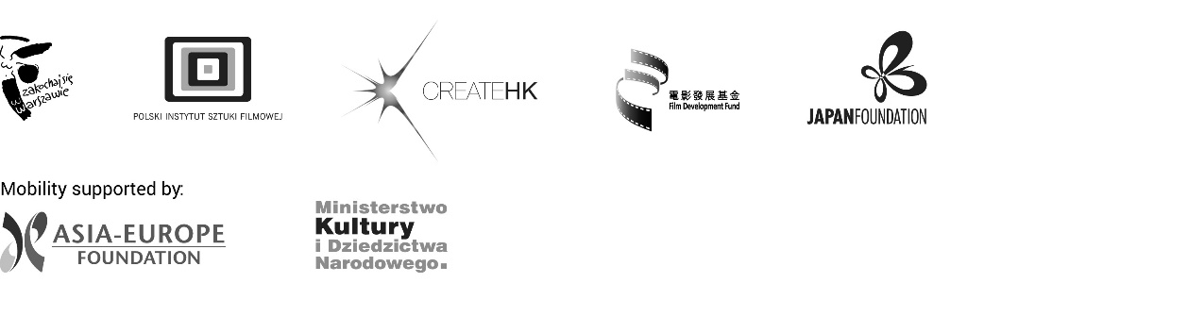

PARTNERS

MEDIA

